**KATHMANDU UNIVERSITY**

**DEPARTMENT OF ELECTRICAL & ELECTRONICS ENGINEERING**

**FINAL PROJECT REPORT**



FAULT DETECTION IN DISTRIBUTION LINE AND PROTECTION OF DEVICES

A **Third year project report** submitted in partial fulfilment

of the requirements for the degree of

Bachelor of Engineering

SUBMITTED BY

PUJAN THAPA MAGAR (32027)

ABHIJEET CHAUDHARY (32033)

ASHIP CHAUDHARY (32034)

YUBRAJ CHIMORIYA (32039)

March 2021

CERTIFICATION

THIRD Year Project Report

on

FAULT DETECTION IN DISTRIBUTION LINE AND PROTECTION OF DEVICES

By:

Pujan Thapa Magar (32027)

Abhijeet Chaudhary (32033)

Aship Chaudhary (32034)

Yubraj Chimoriya (32039)

Approved by:

1. Project Supervisor

___________________ Assoc.Prof. Brijesh Adhikary _______

(Signature) (Name) (Date)

2. Head of the Department

___________________ Dr. Sailendra kr. Jha _______

(Signature) (Name) (Date)

# ABSTRACT

Electricity has become the basic needs for living. Gone are the days when electricity would be only limited to cities. It is now reaching to every distant parts of the world. So, we have now a complex network of power system. This power is being carried by the transmission lines and distribution lines. These lines travel very long distances so while carrying power, fault occurring is natural. These faults damage many vital electrical equipment like transformer, generator, etc. For the uninterrupted power supply we need to prevent these faults as much as possible. So we need to detect faults within the shortest possible time. Microprocessors and microcontroller based systems used for these fault detection have been advancing rapidly.

This project is about designing the arduino based system where the fault is detected and classified when the input value deviates from stable value set in the relay which then gives the trip signal to the circuit breaker or contactor.

# ACKNOWLEDGEMENT

It gives us an immense pleasure to present this report, focused on our project entitled "FAULT DETECTION IN DISTRIBUTION LINE AND PROTECTION OF DEVICE". This report has been prepared with the aim of recording the ideas and basic knowledge achieved by our team members during the project hours, to fulfill partial fulfillment of the requirements for the degree of Bachelor of Engineering. Our heart full thanks goes to Kathmandu University, department of Electricals & Electronics for organizing engineering project ENGG 102.

Also, we would like to thank our Project Coordinator, Asst.Prof.Dr.Anup Thapa, Supervisor, Assoc.Prof. Brijesh Adhikary and faculty for their support throughout the project. Also, we would like to thank Mr. Nashib Khadka, Research Assistant at Center for Electrical Power Engineering for his valuable suggestions and experts. Well, we can't remain without giving thanks to our family members and friends who always supported us in the time of various difficulties.

Any suggestions and feedbacks are warmly welcomed.

# ABBREVIATIONS

|  |  |  |
| --- | --- | --- |
| Abbreviation | Full form | First used in page |
| CT | Current Transformer | 4 |
| PT | Potential Transformer | 4 |
| LG | Line to ground fault | 4 |
| LLG | Double Line to ground fault | 4 |
| LLLG | Triple Line to ground fault | 4 |
| PF | Power Factor | 4 |
| LV | Low Voltage | 5 |
| MV | Medium voltage | 5 |
| ADC | Analogue to digital Converter | 9 |
| KV | Kilo volt | 10 |
| AC | Alternating Current | 10 |
| DC | Direct Current | 10 |
| IOT | Internet of Things | 12 |
| LCD | Liquid Crystal Display | 13 |
| SMS | Short Message Services | 13 |
| NO | Normally Open | 17 |
| NC | Normally Closed | 17 |
| TTL | Transistor Transistor Logic | 21 |
| IDE | Integrated Development Environment | 21 |

# LIST OF FIGURES

|  |  |  |
| --- | --- | --- |
| Figure No. | Title | Page No. |
| 1.1 | Radial distribution system | 5 |
| 1.2 | Parallel feeders distribution system | 5 |
| 1.3 | Ring main distribution system | 5 |
| 1.4 | Interconnected distribution system | 6 |
| 1.5 | LLL-G fault and LLL fault | 9 |
| 1.6 | Asymmetric fault | 9 |
| 1.7 | Block diagram of the system | 11 |
| 1.8 | Center tapped step down transformer | 12 |
| 1.9 | Full wave center tapped rectifier with filter | 13 |
| 2.0 | Voltage regulator 7806 IC | 13 |
| 2.1 | Relay | 14 |
| 2.2 | Contactor | 15 |
| 2.3 | Hold switch | 15 |
| 2.4 | LCD Display | 16 |
| 2.5 | Arduino Uno | 16 |
| 2.6 | Circuit diagram of overall system | 17 |
| 2.7 | Flow chart for fault distance of R phase | 19 |
| 2.8 | Flowchart for function fault distance | 20 |
| 2.9 | Flowchart for classification of fault | 21 |
| 3.0 | Simulation: RMS current and voltage measurement | 25 |
| 3.1 | Simulation: Phase angle measurement | 26 |
| 3.2 | Simulation: When there is no fault at distribution line | 27 |

# TABLE OF CONTENTS

ABSTRACT iii

ACKNOWLEDGEMENT iv

ABBREVIATIONS v

LIST OF FIGURES vi

TABLE OF CONTENTS vii

CHAPTER 1: INTRODUCTION 1

1.1 Introduction and background 1

1.2 Problem Definition 1

1.4 Objectives 2

1.5 Limitations 2

1.6 Methodology 2

1.7 Synopsis 3

1.8 Summary 3

CHAPTER 2: TECHNOLOGY AND LITERATURE SURVEY 4

2.1 Mathematical Concept 4

2.1.1 Single line to ground fault 4

2.1.2 Line to Line fault 4

2.2 Distribution Lines 4

2.2.1 Primary Distribution line 4

2.2.2 Secondary Distribution Line 4

2.2.3 Configuration of Distribution network 4

2.3 Choice of conductor 6

2.4 Introduction to fault 7

2.4.1 Nature and causes of fault 7

2.4.2 Types of fault 8

2.5 Related work 10

2.6 Summary 10

CHAPTER 3 METHODOLOGY 11

3.1 System Overview 11

3.2 Working Principle……………………………………………………………………..12

3.3 Component Selection 12

3.3.1 Center tapped step down transformer (12-0-12) 12

3.3.2 Diodes and capacitor for rectification 13

3.3.3 7806 as a voltage regulator. 13

3.3.4 Relay 14

3.3.5 Contactor 15

3.3.6 Hold Switch 15

3.3.7 LCD Display 16

3.3.8 Circuit Diagram of system 17

3.4 Flowchart for Aurdino programme 19

3.4.1 Flowchart for calculating fault distance 19

3.4.2 Flowchart for classification of fault 21

3.5 Gantt Chart 22

3.6 Summary 23

CHAPTER 4: SYSTEM ANALYSIS AND RESULT 24

4.1 Proteus Simulation 25

4.1.1 Simulation: RMS current and voltage measurement 25

4.1.2 Simulation: Phase angle measurement 26

4.1.3 Simulation: When there is no fault at distribution line 26

4.1.4 Simulation: When there is single line to ground fault at 2 KM. 27

4.1.5 Simulation: When there is double line to ground fault at 4 KM. 27

4.1.6 Simulation: When there is triple line to ground fault 28

4.2 Hardware Implementation 30

4.3 Features of the final project 31

4.4 Cost Estimation of project 32

4.5 Summary 33

CHAPTER 5: CONCLUSION AND FUTURE RECOMMENDATION 34

REFERENCES…………………………………………………………………………….....35

APPENDIX A: DATASHEET……………………………………………………………….35

APPENDIX B: CODE FOR FINAL HARDWARE 36

LCD Programme 36

Code for serial monitor 39

# CHAPTER 1: INTRODUCTION

## 1.1 Introduction and background

Electrical faults in a power system must be cleared fast in order to prevent people and property from damage or injury. In the early days of electrical power systems, the maintenance staff cleared the fault, who visually detected the fault and manually operated a switch to clear the fault. As fault currents became larger and the operating requirements of the electric power system became more advanced, the need for automatic fault clearance became a necessity. A typical fault clearing system consists of a circuit breaker and a relay protection system.

In the early days of automatic fault clearing, a fault was detected by electromechanical relays. The measured quantity, such as for exampe a voltage or a current, was transformed to a mechanical force that operated the relay when a preset threshold was exceeded. Following the advent of electronics such as transistors and operational amplifiers, solid-state relays were developed. The characteristic of such relays were implemented by circuit design. Today, new relays are normally numerical relays. They are built around a microprocessor in which the relay characteristic is digitally implemented. The recent development of fast microprocessors has led to the possibility to implement highly sophisticated relay characteristics within the microprocessor.

After a fault in distribution or transmission network, circuit breakers are tripped due to the metallic characters present in circuit breakers. But the real challenge is to classify which type of fault occurs and where the fault took place. The measurement transducers in substation should be able to detect the peak voltage and peak current during the fault of each phase. And the microprocessors in the control room should classify the type of fault based on those peaks before the faults damages the property. Also control room should be able to separate healthy line and faulty line so that every consumers shouldn't be affected by blackout.

This project demonstrates a simple distribution network (3 phase 4 wire system, 12 Volt line-neutral, 8 KM, 500 ohm per KM) which detects and locates the fault present in the power distribution line caused by various natural or manmade forces. These faults directly affects the customers so that it must be found out and clear the fault as fast as possible. This is done by placing individual proposed fault detection units on each feeder, which consists of set of voltage sensor. Using sensor values, the system checks whether there is any fault is present on the line or not.

This project works based on ohms law, the return voltage drop at the end of the neutral line alters depending on the location of fault. The cable in overhead line have resistance. Neglecting capacitance and inductance in this project, the resistance of the network is 500 ohm per KM. So, depending on the fault location the voltage drop varies.

## 1.2 Problem Definition

In technologically behind country like Nepal, the distribution line fault is a serious issue and we detect and locate those faults manually. When fault appears in the distribution line, the users should inform the authorities. This takes long time since the officials from the electrical authority should survey and locate the faulty area. Also, due to various environmental and geographical conditions in rural areas manual fault detection is time consuming and costly. Due to this consumers have to face blackout problems even in the healthy line. The distribution lines are obstructed by various natural and human causes namely fallen trees, large transport systems, breakage of electric poles, lightening, etc. Those faults effect various home appliances along with instruments in generation and distribution unit. After detection and classification of fault, it is easy to determine the location of faulty point. Various technologies are developed like Composite Fiber Optic Overhead Ground Wire (OPGW),Fault Detection Using Neural Network, Impedance based method etc.

## 1.3 Motivation

In rural parts of Nepal, due to geographical difficulties, the survey for determining the fault location is hard. So, once fault occurs the power is back after one or two days. These types of news are regular in social media. Those news motivates project members to study and research on fast detection of fault location.

Also, being power student study on distribution network, various parameters involved, challenges involved on distribution network was subject of interest.

## 1.4 Objectives

The main objectives of the proposed project are listed below:

* To detect and classify type of fault in 3-phase line.
* To find the approximate location of fault from substation.
* To communicate the control room about the faulty area.

## 1.5 Limitations

The project is limited to following:

* Loads are not used in this project since distribution line is of 12 volt to neutral.
* The project can only detect LG, LLG, LLLG fault.

## 1.6 Methodology

Various tools are used for doing this project:

* Literature Review on Power System from generating station to Distribution network. Members also researched on distribution substation and how control room works. Also, basic study on different machines like CT, PT, Circuit Breaker, Contactor, Relays, conductors used in distribution line.
* Arduino Programme to control microprocessor in high level languages.
* Proteus 8 was used for simulation where single phase voltage, current, pf, and frequency was measured. Also, the simulation of final project was done.
* Matlab simulation was used to simulate various faults.

## 1.7 Synopsis

This report is presented into five different chapters. The different chapters include details of the different phase of the system development.

In Chapter 1, all the processes that were done before the initiation of the project is included. Mainly, this section provides the information in the processes presented in the initial proposal. The introduction section gives detail into the background of the system, and the system’s objectives. It also includes the process we followed while doing this project in brief.

In Chapter 2, the different type of approaches used by the system is included. It also includes the brief paragraph on the paper which are related to this project and also includes different study about the distribution network and its properties.

In chapter 3, the process of system development, all the components were studied and a block diagram was formulated on how the system works. This section deals with how those components work together. Also, in this chapter the circuit diagram of the final project is included. At the end of this chapter, flowchart for the aurdino programme is included.

In chapter 4, after all the system development work was done, the system was analyzed. The system was simulated using proteus and voltage and current profiles were seen. Also, the values were calculated using formula and compared with the observed value.

In chapter 5, the conclusion provides the overall view of the report. It also provides the suggestion for improvement of the system.

## 1.8 Summary

This chapter briefly introduce the topic. It also discusses a brief history on fault clearing system. In section 1.1, it introduces the basic principle behind this project. The motivation and objective behind this project are also listed in 1.3 and 1.4 respectively. The methodology used to complete this project is included in section 1.6.

# CHAPTER 2: TECHNOLOGY AND LITERATURE SURVEY

## 2.1 Distribution Lines

Electricpowerdistribution is the final stage in the delivery of electric power. It carries electricity from the transmission system to individual consumers. Distribution substations connect to the transmission system and lower the transmission voltage to medium voltage ranging between 2 kV and 35 kV with the use of transformers. Primary distribution lines carry this medium voltage power to distribution transformers located near the customer's premises. Distribution transformers again lower the voltage to the utilization voltage used by lighting, industrial equipment and household appliances. Often several customers are supplied from one transformer through secondary distribution lines. Commercial and residential customers are connected to the secondary distribution lines through service drops.

### 2.1.1 Primary Distribution line

Primary distribution voltages range from 4 kV to 35 kV phase-to-phase. Only large consumers are fed directly from distribution voltages; most utility customers are connected to a transformer, which reduces the distribution voltage to the low voltage used by general public.

### 2.1.2 Secondary Distribution Line

Low-voltage network or secondary network is a part of electric power distribution which carries electric energy from distribution transformers to electricity meters of end customers.

Secondary networks are operated at a low voltage level, which is typically equal to the mains voltage of electric appliances. Most modern secondary networks are operated at AC rated voltage of **230–240 volts,** at the frequency of 50 or 60 hertz.

### 2.1.3 Configuration of Distribution network

An electric power distribution system can be classified according to its feeder connection schemes or topologies as follows:

* Radial distribution system
* Parallel feeders distribution system
* Ring main distribution system
* Interconnected distribution system

#### 2.1.3.1 Radial distribution system

This system is used only when substation or generating station is located at the center of the consumers. In this system, different feeders radiate from a substation or a generating station and feed the distributors at one end. The radial system is employed at low voltage and the substation is located at the center of the load.

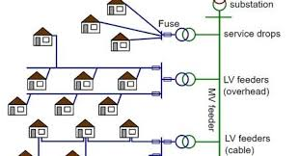

Fig 1.1 Radial distribution system

#### 2.1.3.2 Parallel feeders distribution system

The above-mentioned disadvantage of a radial system can be minimized by introducing parallel feeders. The initial cost of this system is much more as the number of feeders is doubled. Such system may be used where reliability of the supply is important or for load sharing where the load is higher.

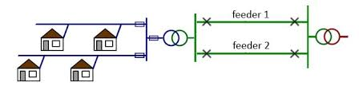

Fig 1.2 Parallel feeders distribution system

#### 2.1.3.3 Ring main distribution system

Here, each distribution transformer is fed with two feeders but in different paths. The feeders in this system form a loop which starts from the substation bus-bars, runs through the load area feeding distribution transformers and returns to the substation bus-bars.

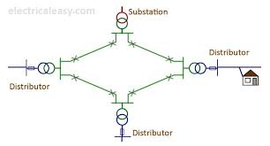

Fig 1.3 Ring main distribution system

#### 2.1.3.4 Interconnected distribution system

When a ring main feeder is energized by two or more substations or generating stations, it is called as an interconnected distribution system. This system ensures reliability in an event of transmission failure. Also, any area fed from one generating stations during peak load hours can be fed from the other generating station or substation for meeting power requirements from increased load.

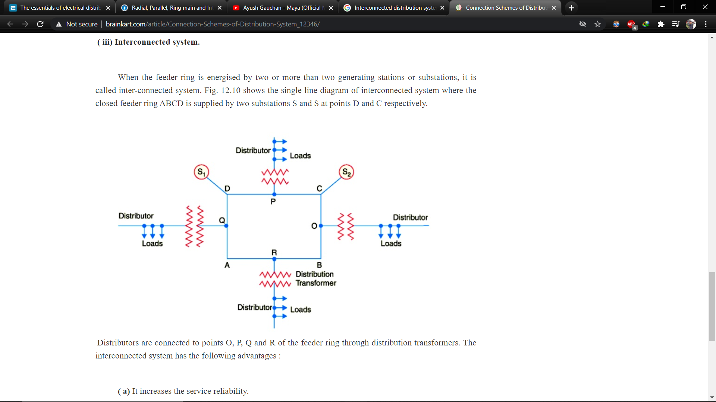

#### Fig 1.4 Interconnected distribution system

## 2.2 Choice of conductor

In power distribution system both aluminum and ACSR are commonly used. Mostly aluminum conductors are used in the distribution system because of cheaper in cost. Some of the factors which decides the size of the conductors designed for distribution system are given below:

* **Maximum continuous current rating:** While choosing the conductor size for continuous rating, proper care should be taken of all the rating factors depending on actual conditions of installation. Like any other equipment selection, current carrying rating of the cable is governed by permissible rise in temperature of the cable which the insulation provided to the cable should have to withstand. This depends on the amount of heat produced and the surrounding temperature of the soil. The current rating of the cable apart from the above factors also depends on the large number of factors such as method of cable laying employed, spacing between the cables, number of cores of the cable and thermal conductivity of the soil.
* **System Earthing:** The unearthed system will require full insulation from the core to the ground and the cable will be costly compared to the earthed system. For un-earthed cables, more insulation is provided in order to withstand the higher voltage stresses during the short circuit faults.
* **Voltage drop:** The cable should be selected such a way that at full load, the voltage drop should be within the permissible limits.
* **Conditions of installation:** Methods of installation, estimated thermal resistivity of soil, type of covering, type of armoring, the need if any for additional corrosion protection.
* **Expected Short Circuit Level of System:** On the basis of the expected short circuit current and time of clearance, an appropriate conductor size for the cable may be selected. The cables should be selected such that it has to withstand stresses and temperature rise in the event of short circuit faults.
* **Temperature rise:** During short circuit temperature of cable rises, cables should be able to withstand the rise in temperature for a prescribed duration without getting damage. It has to allow continuous current during normal operation without rise in the temperature and should be within desired limits.
* **Economic evaluation:** One of the important factors to be considered while choosing the cable is cost evaluation.

## 2.3 Introduction to fault

Fault is simply defined as a number of undesirable but unavoidable incidents can temporarily disturb the stable condition of the power system that occurs when the insulation of the system fails at any point. Moreover, if a conducting object comes in contact with a bare power conductor, a short circuit, or fault, is said to have occurred. The causes of faults are many, they include lighting, wind damage, trees falling across transmission lines, vehicles or aircraft colliding with the transmission towers or poles, birds shorting lines or vandalism.

### 2.3.1 Nature and causes of fault

Following are some of the main causes:

* Lightning
* Pollution
* Fires
* Others

#### 2.3.1.1 Lightning

More than half of the electrical faults occurring on overhead power lines are caused by lightning. The main conventional approaches for reduction of the lightning flashover faults on power lines are lowering of the footing resistance and employing of multiple shielding wires, and differential insulation.

However, these methods have not been sufficient to prevent flashover faults. In the meantime, application of arresters to lines has been a better solution in recent years. This alternate approach is to install an arrester to prevent the flashover of insulator assemblies. It is important that the arrester should be strong enough in order to withstand excessive lightning strikes. A newly developed suspension-type line arrester has been developed by incorporating ZnO elements into the shed of a conventional suspension insulator. It has an arrester function along with the normal electrical and mechanical functions of a line insulator. It is a gapless type that has the advantage of reliable surge absorption with no delay in discharge. The new arrester holds promise not only for the prevention of lightning faults, but also as means of achieving economical insulation in the overall distribution systems.

#### 2.3.1.2 Pollution

Pollution is commonly caused by deposited soot or cement dust in industrial areas, and by salt deposited by wind-borne sea-spray in coastal areas. A high degree of pollution on an insulator string, although it reduces the insulation strength of the affected phase, does not become a fault until it causes a flashover across the string, which in turn reduces excess current or other detectable abnormality, for example abnormal current in an arc-suppression coil.

#### 2.3.1.3 Fires

The occurrence of fire under distribution lines is responsible for a great number of line outages in many countries. Faults are mainly due to conductor to ground short circuit at mid-span or phase-to-phase short circuit depending on line configuration and voltage level. To reduce these outages to a minimum, the clearance of existing lines must be increased in forests. Clearing and vegetation on the line right of way in such areas is also a consideration. Another problem arising from burning is the contamination of the insulators due to the accumulation of particles (soot, dust) on its surfaces. In this case, the line insulation requirements should be determined in such a way that the outages under fire could be reduced to a minimum.

#### 2.3.1.4 Other factors

Other factor includes various environmental factors like: trees, birds, aircraft, fog, ice, snow loading, punctured or broken insulators, open-circuit conductors etc.

### 2.3.2 Types of fault

#### 2.3.4.1 Transient Fault

#### A transient fault is a fault that is no longer present if power is disconnected for a short time and then restored; or an insulation fault which only temporarily affects a device's dielectric properties which are restored after a short time. Many faults in overhead power lines are transient in nature. When a fault occurs, equipment used for power system protection operate to isolate the area of the fault. A transient fault will then clear and the power-line can be returned to service. Typical examples of transient faults include:

* momentary tree contact
* bird or other animal contact
* lightning strike
* conductor clashing

#### 2.3.4.2 Symmetric Fault

A symmetric or balanced fault affects each of the three phases equally. In transmission line faults, roughly 5% are symmetric. This is in contrast to an asymmetrical fault, where the three phases are not affected equally. These faults rarely occur in practice as compared with unsymmetrical faults. Two kinds of symmetrical faults include line to line to line (L-L-L) and line to line to line to ground (L-L-L-G). A rough occurrence of symmetrical faults is in the range of 2 to 5% of the total system faults. However, if these faults occur, they cause a very severe damage to the equipment even though the system remains in balanced condition.

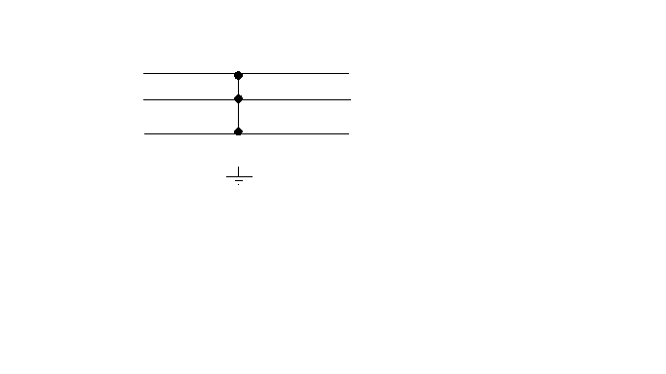

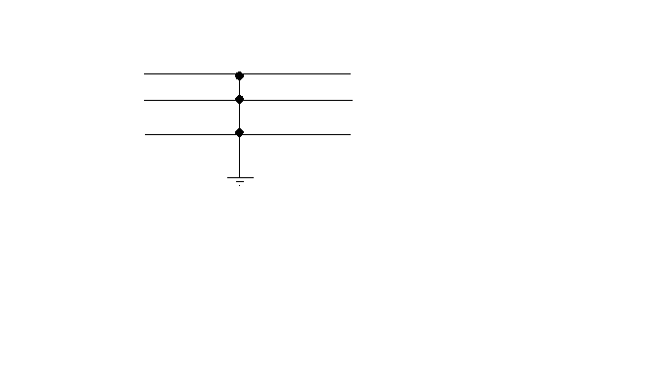

Fig1.5 Symmetric fault : LLL-G fault and LLL fault

#### 2.3.4.3 Asymmetric Fault

An asymmetric or unbalanced fault does not affect each of the three phases equally. Common types of asymmetric faults, and their causes:

• Line-to-line - a short circuit between lines, caused by ionization of air, or when lines come into physical contact, for example due to a broken insulator. In transmission line faults, roughly 5% - 10% are asymmetric line-to-line faults.

• Line-to-ground - a short circuit between one line and ground, very often caused by physical contact, for example due to lightning or other storm damage. In transmission line faults, roughly 65% - 70% are asymmetric line-to-ground faults.

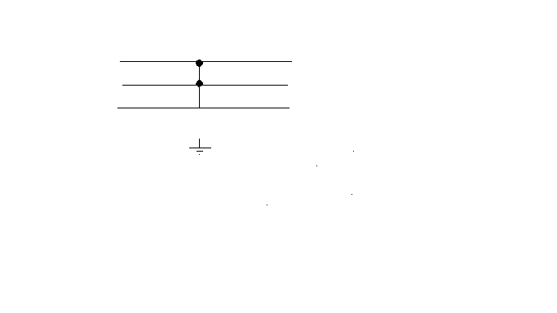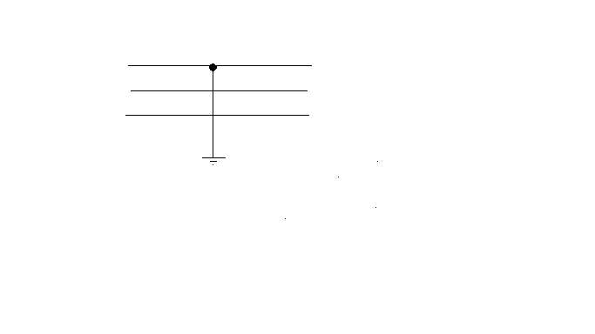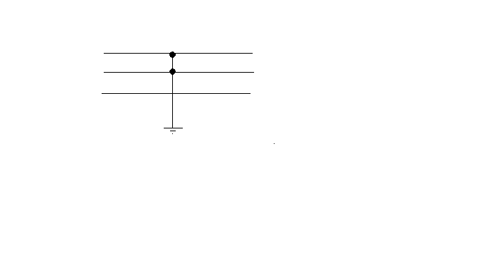• Double line-to-ground or line to line to ground fault - two lines come into contact with the ground (and each other), also commonly due to storm damage. In transmission line faults, roughly 15% - 20% are asymmetric double line-to-ground.

Fig: 1.6 Asymmetric fault : LL-G fault, L-G fault and LL fault

## 2.4 Mathematical Concept

Fault or short-circuit studies are obviously an essential tool for the electric energy systems engineer. The task here is to be able to calculate the fault conditions and to provide protective equipment designed to isolate the faulted zone from the remainder of the system in the appropriate time. The least complex category computationally is the balanced fault. This tempts the engineer to base his decision on its results. The balanced fault could (in some locations) result in currents smaller than that due to any other type of fault. However, the interrupting capacity of breakers should be chosen to accommodate the largest of fault currents.

### 2.4.1 Single line to ground fault

Assume that the phase a is shorted to ground at the fault point F. Phase b and c currents are assumed to be negligible, and we can thus write,



The sequence currents are obtained as follows:

To find the positive sequence value we use:



This gives:



For the negative sequence current, we have



This gives:



Likewise for the zero sequence current, we get:



We can then conclude then that in the case of a single line-to-ground fault, the sequence currents are equal, and we write,



We can now state the solution in terms of phase currents:







### 2.4.2 Line to Line fault

In the case of line-to-line fault a short circuit occurs between two phases. Assuming that phase a is the un-faulted phase. The boundary conditions in this case are:





## 2.5 Related work

We had studied two project submission reports worked to solve above-mentioned problems. The engineering students did both the projects from different university. Both of them used different technology to transfer the data from transmitter section to control room. They also use different method to detect the faults.

Tommey and his team worked on "Automatic Fault Detection and Location of Distribution Lines using IOT. As per the title they used IoT technology to transmit the required information between line unit and control unit. To attain their concept, they used pic16f877 controller, voltage sensor, current sensor, speed sensor, buzzer, temperature sensor, LCD. The project was assembled with a set of resistors representing cable length in Kilometers and fault creation was made by a set of switches at every known KM to cross check the accuracy of the same. The voltage drop across the feeder resistor was given to an ADC which develops a precise digital data which the programmed microcontroller would display the same in Kilometers. The fault occurring at what distance and which phase were displayed on a 20X4 LCD interfaced with the microcontroller. If the temperature higher than the threshold value at that time buzzer and LCD will give information. Calculated values were send to the internet with help of IOT. RTC was used here to time and date reference, that when the event occurs. This method provides a cheap and highly reliable way to locate the faults in the three phase transmission lines and also supports data storage. Hence, this method can be implemented to detect the faults and retrieve the corresponding data anytime.

Krishna K Agarwal P E, Jamwes S Candlish worked on “Automatic fault location and isolation system for electric traction overhead lines”. They developed system which can easily and accurately detect and locate the fault occurred in the power line. It consist of a line unit as well as a master station. The system made use of voltage and current transformers which were placed at different points on the line to detect the fault. Detection includes checking whether the line is faulty or not and if it is, then identifying in which category this fault falls. This could be found out by checking the values of current and voltage transformers. The obtained result was then transmitted to master station so that it can continuously monitor the status of lines. If the line is faulty, the master pushes the line after the faulty one to open. Thus, fault occurred at a point on the line will not affect the next sections of the line. The location where which the fault is occurred is also predicted using this system. The main unit sends an SMS to authorities including the type of fault along with the identification number of post where the fault was found.

## 2.6 Summary

The basic theory and terms behind power system, distribution line and fault clearing system is described in this chapter. In section 2.1, introduction to distribution network, section 2.3 includes configuration of distribution system. Also, in section 2.2 there is brief introduction to the choice of conductors used in overhead lines. Brief explanation of fault start from section 2.4. Also, at the end of the section, literature survey on similar projects is included.

# CHAPTER 3 METHODOLOGY

## 3.1 System Overview

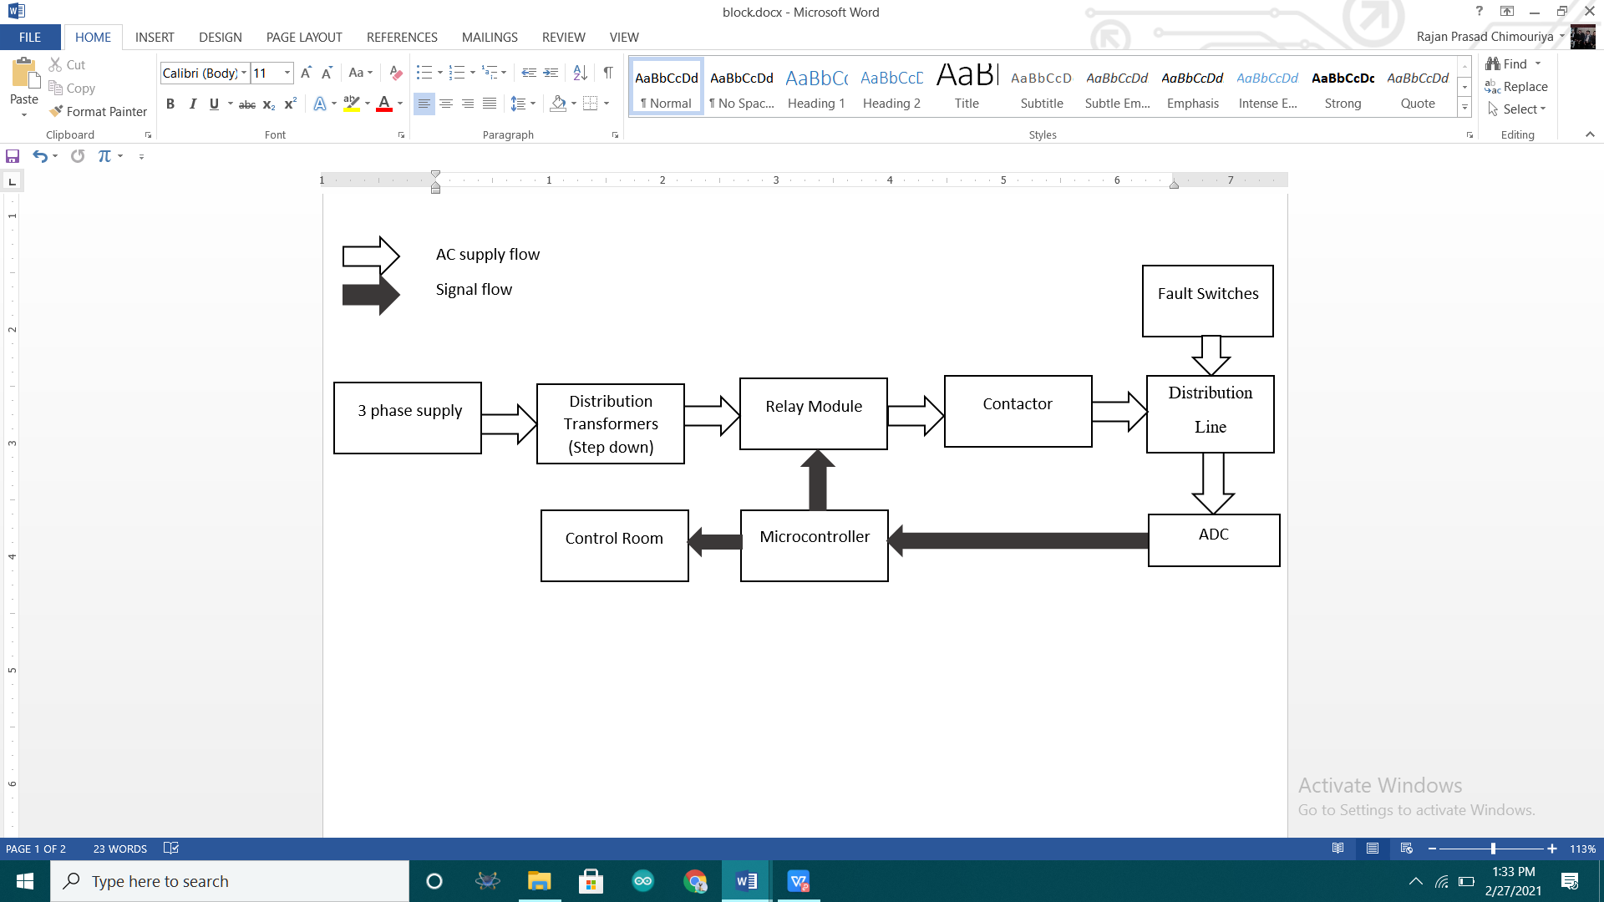

Fig 1.7 Block diagram of the system

The block diagram is shown in above figure. The system for fault detection is placed in distribution substation. Here a single ADC is used in all 3 phases to sense the return voltage. So, a relay module is used to check ADC of all 3 phases turn by turn.

Whenever there is a fault (created manually by switches), return voltage gets generated. This return voltage depends on the location from substation or control room. Any phase to ground voltage at specific location is constant. These voltage is converted into digital using ADC. The relay module turn by turn converts analog value of each phase into digital value.

After detecting fault, ADC sends signal to microprocessor which is compared with the preset value and the distance is found. The classification of fault is also done. After detecting fault microcontroller sends signal to relay which breaks the line through contactor.

The system will inform continuously, the condition of the system to the control room.

## 3.2 Working Principle

The system uses the standard theory of ohm's law, i.e. when a low voltage is applied at the feeder end through a series resistor (distribution line), then the current would vary depending upon the location of the fault as the resistance of the cable is proportional to the distance. This is then fed to an ADC to develop precise digital data. This ADC value is programmed in such a way that arduino can locate the fault distance and classify the type.

## 3.3 Component Selection

### 3.3.1 Center tapped step down transformer (12-0-12)

Three center tapped step down transformer is selected for this project. Each transformer step down each phase 220 volt line to neutral into 12 volt to neutral.

Also, from one transformer AC is rectified to DC for providing coil voltage of DC 6 volt to relay module.

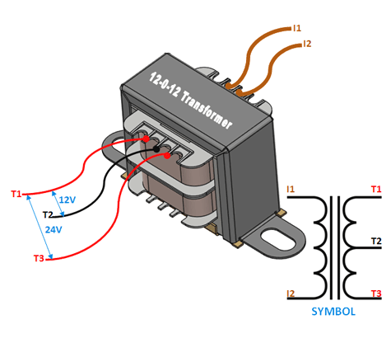

Fig 1.8 Center tapped step down transformer

The operation and theory behind a Center tapped transformer is very similar to a normal secondary transformer. A primary voltage will be induced in the primary coil (I1 and I3) and due to magnetic induction the voltage will be transferred to the secondary coil. Here in the secondary coil of a centre tapped transformer, there will be an additional wire (T2) which will be placed exactly at the center of the secondary coil, hence the voltage here will always be zero.

If we combine this zero potential wire (T2) with either T1 or T2, we will get a voltage of 12V AC. If this wire is ignored and voltage across T1 and T2 is considered then we will get a voltage of 24V AC. This feature is very useful for the function of a full wave rectifier.

Some features of transformer selected for the project are:

* Step-down Centre tapped Transformer
* Input Voltage: 220V AC at 50Hz
* Output Voltage: 24V, 12V or 0V
* Output Current: 500 ma
* Vertical mount type
* Low cost and small package
* Available at KU lab.

### 3.3.2 Diodes and capacitor for rectification

As mentioned in section 3.2.1, DC 6 volt is required for operation of relay module. The full wave rectification circuit is shown below:

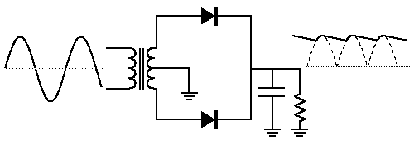

Fig 1.9 Full wave center tapped rectifier with filter

The features of using center tapped full wave rectifier are:

* Center Tapped rectifier converts both halves of the AC input cycle into DC output.
* The rectifier uses a tapped transformer and two diodes and the tapping is grounded.
* The average output of the center-tapped rectifier is twice that of a half-wave rectifier.
* The ripple voltage is less than that of a half-wave rectifier.
* The output voltage can be controlled with a change in turn ratio.

### 3.2.3 7806 as a voltage regulator.

A regulated voltage of 6 voltage is needed to operate relay module. The output from rectification is unregulated 12 volt. This 12 volt is feed into 7806 input pin to get regulated 6 voltages.

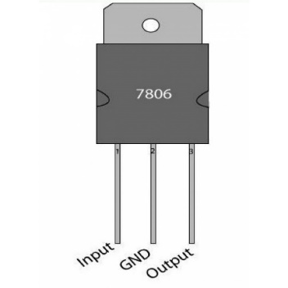

Fig 2.0 voltage regulator 7806 IC

### 3.2.4 Relay

Four 6 voltage relays are selected for this project. 3 are used for controlling 3 phases and 1 relay is used for controlling contractor. Relays are driven by relay driver IC 2803 which is described in section 3.2.5.

Relays are switches that open and close circuits electromechanically or electronically. Relays control one electrical circuit by opening and closing contacts in another circuit. As relay diagram 2.1 shows, when a relay contact is normally open (NO), there is an open contact when the relay is not energized. When a relay contact is Normally Closed (NC), there is a closed contact when the relay is not energized. In either case, applying electrical current to the contacts will change their state.

Relays are generally used to switch smaller currents in a control circuit and do not usually control power consuming devices except for small motors and Solenoids that draw low amps. Nonetheless, relays can "control" larger voltages and amperes by having an amplifying effect because a small voltage applied to a relays coil can result in a large voltage being switched by the contacts. Protective relays can prevent equipment damage by detecting electrical abnormalities, including overcurrent, undercurrent, overloads and reverse currents. In addition, relays are also widely used to switch starting coils, heating elements, pilot lights and audible alarms.

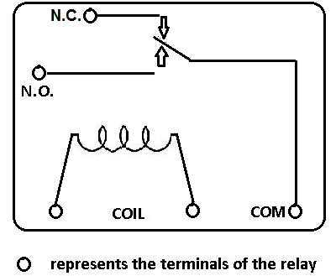

Fig 2.1 Relay

### 3.2.5 Relay driver 2803

ULN2803 is high current as well as high voltage Darlington transistor array. Usually, the chips is used to operate on the low-level signals. All these chips operate at either 0 volts or 5 volts thus these are not capable of driving loads of high inductive power. The ULN2803 chips take the low-level signals at input side i.e. TTL and make use of that low-level signal in switching off loads of higher voltage present at the output side.

### 3.2.6 Contactor

Basically, a contactor is an electrical switching device. It is used for switching an electrical circuit on and off. It is a special type of relay, but there is a basic difference between the contactor and a relay. The contactor is mostly used in applications where higher current carrying capacity is involved, while the relays are used for lower current applications. Contactors are compact and can be field mounted easily. Usually, these devices feature multiple contacts. The contacts are mostly normally open, and they provide operating power to the load whenever the contactor coil is powered. Contactors are popularly used with electric motors.

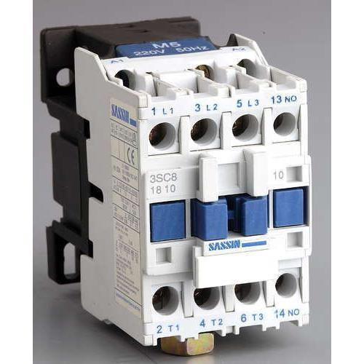

Fig 2.2 Contactor

Contactors are most commonly used with high-current load because of their capability to handle current well over 5000 amperes and high power well over 100 kW. When heavy motor currents are interrupted, they produce arcs. A contactor can be used to reduce and control these arcs.

### 3.2.7 Hold Switch

Twelve hold switches are used in this project. NO of the switches are connected between each phase and ground. So, when pressed, there will be short and faults are created.

### 

Fig 2.3 Hold switch

### 3.2.8 LCD Display

The term LCD stands for liquid crystal display. It is one kind of electronic display module used in an extensive range of applications like various circuits & devices like mobile phones, calculators, computers, TV sets, etc. These displays are mainly preferred for multi-segment light emitting diodes and seven segments. The main benefits of using this module are inexpensive; simply programmable, animations, and there are no limitations for displaying custom characters, special and even animations, etc.

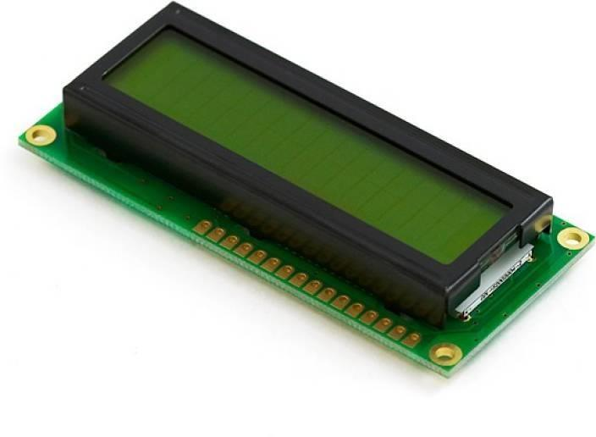

Fig 2.4 LCD display

### 3.2.9 Aurdino Uno

It is a microcontroller board based on the ATmega328P. It has 14 digital input/output pins (of which 6 can be used as PWM outputs), 6 analog inputs, a 16 MHz ceramic resonator (CSTCE16M0V53-R0), a USB connection, a power jack, an ICSP header and a reset button. It contains everything needed to support the microcontroller; simply connect it to a computer with a USB cable or power it with AC-to-DC adapter or battery to get started. We can tinker with our UNO without working too much about doing something wrong, worst case scenario we can replace the chip for a few dollars and start over again. "Uno" means one in Italian and was chosen to mark the release of Arduino Software (IDE) 1.0. The Uno board and version 1.0 of Arduino Software (IDE) were the reference versions of Arduino, now evolved to newer releases. The Uno board is the first in a series of USB Arduino boards, and the reference model for the Arduino platform; for an extensive list of current, past or outdated boards see the Arduino index of boards.

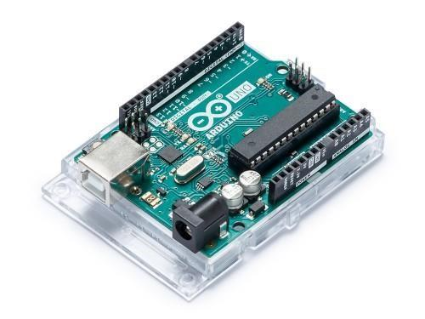

Fig 2.5 Arduino Uno

## 3.3 Circuit Diagram of system

Fig 2.6 Circuit diagram of overall system

Components used:

V1 = 3 phase voltage source, 220 volt line to neutral, 50 Hz

RL1, RL2, RL3 = Relays; Part of relay module

2803 IC = Relay driver; Part of relay module

Resistors*17 = 1K ohm each; Part of distribution line

Hold switches* 12 = To create fault manually

Center tapped transformer *3 = Not shown in circuit but are used in hardware to step down 220 volt to 12 volt

The distribution network of the prototype consists of 3 phase 4 wire system. In each phase, 4 equal resistor are used; each resistor represents 2 KM distance. After each node of resistor, a NO of switch is connected and the common of switch is connected to the neutral/ground. When switch is pressed, return voltage (voltage across R17) is read by arduino analogRead() function. When there is no fault, the voltage across R17 is 0 volt. When the fault is created by switch the voltage reading varies depending on the distance at which fault is created. And the remaining work is program. The flowchart on how the fault type is classified is mentioned in section 3.4.

## 3.4 Flowchart for Arduino programme

### 3.4.1 Flowchart for calculating fault distance

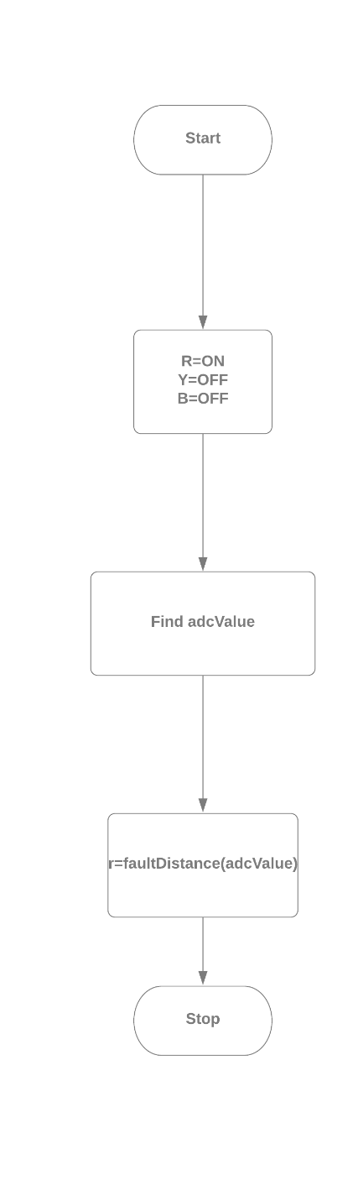

Fig 2.7 Flow chart for fault distance of R phase

This flow chart is for finding fault location of R phase. To find fault location for Y phase, set Phase Y ON and phase B and phase R OFF. Similarly, to find fault location for B phase, set Phase B ON and phase R and phase Y OFF.

The flow chart for **faultDistance(adcValue)** function is shown in figure 2.8.

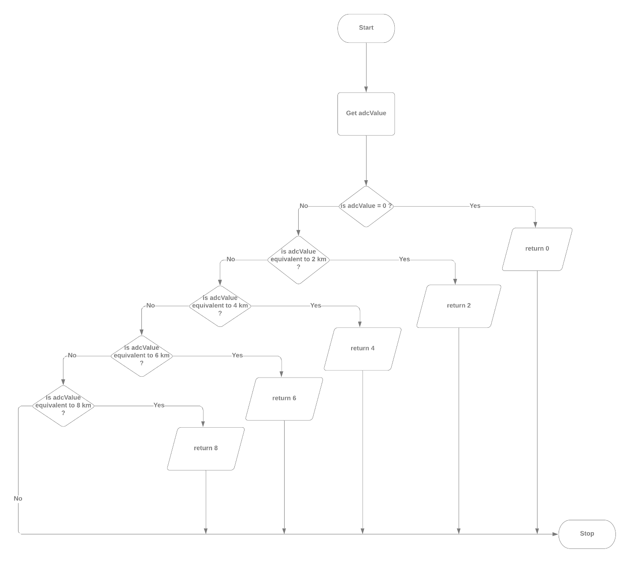

Fig 2.8 Flowchart for function fault distance

After getting ADC value using flowchart in figure 2.7, then flowchart at figure 2.8 can be used to dind the distance at which fault is located. If ADC value is equivalent to 0, then there is no fault. Similarly, the range of different ADC determines different location. This is because ADC is proportional to return voltage which is proportional to distance at which fault is created.

The flowchart to classify type of fault is mentioned in section 3.4.2.

### 3.4.2 Flowchart for classification of fault

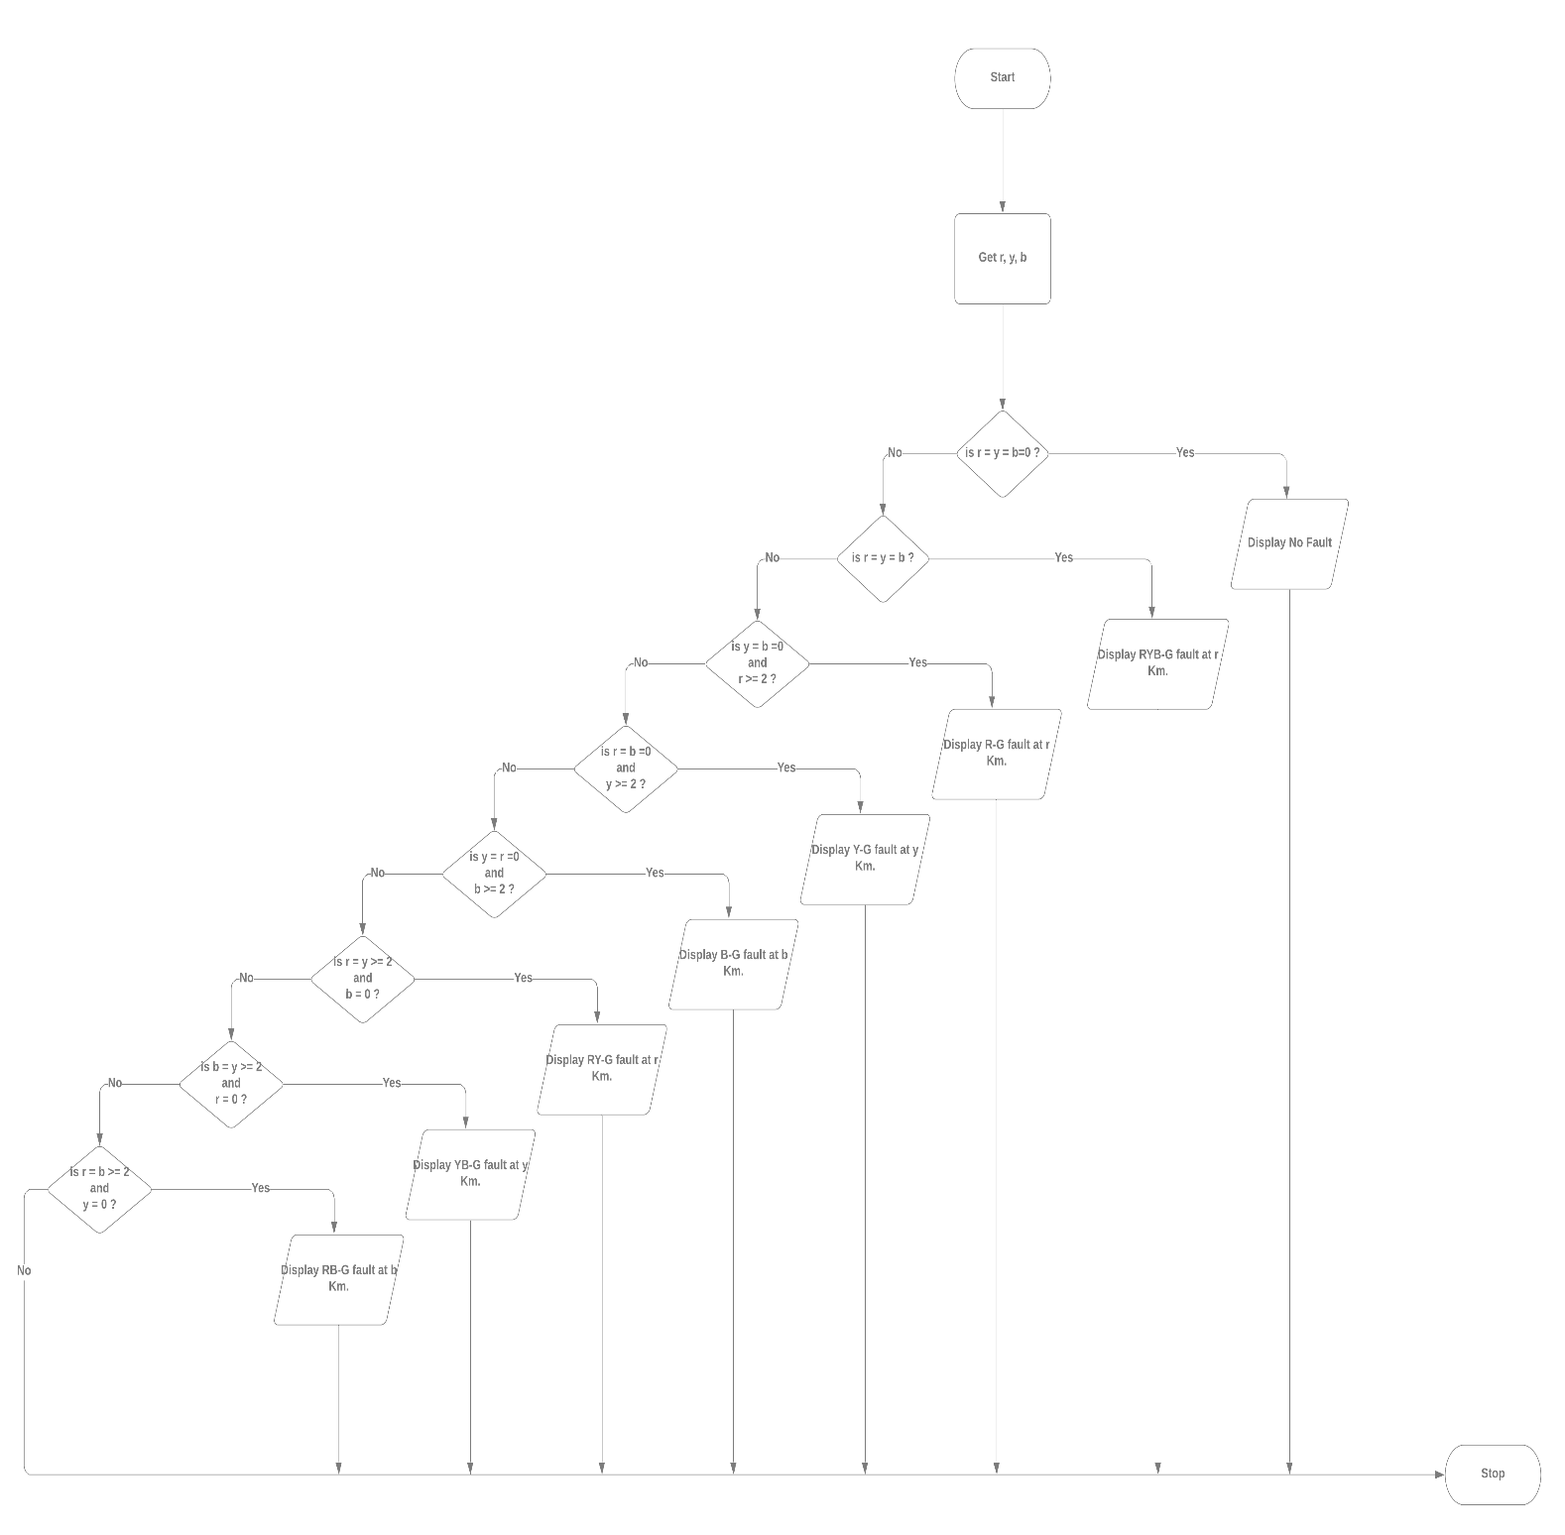

Fig 2.9 flowchart for classification of fault

## 3.5 Gantt Chart

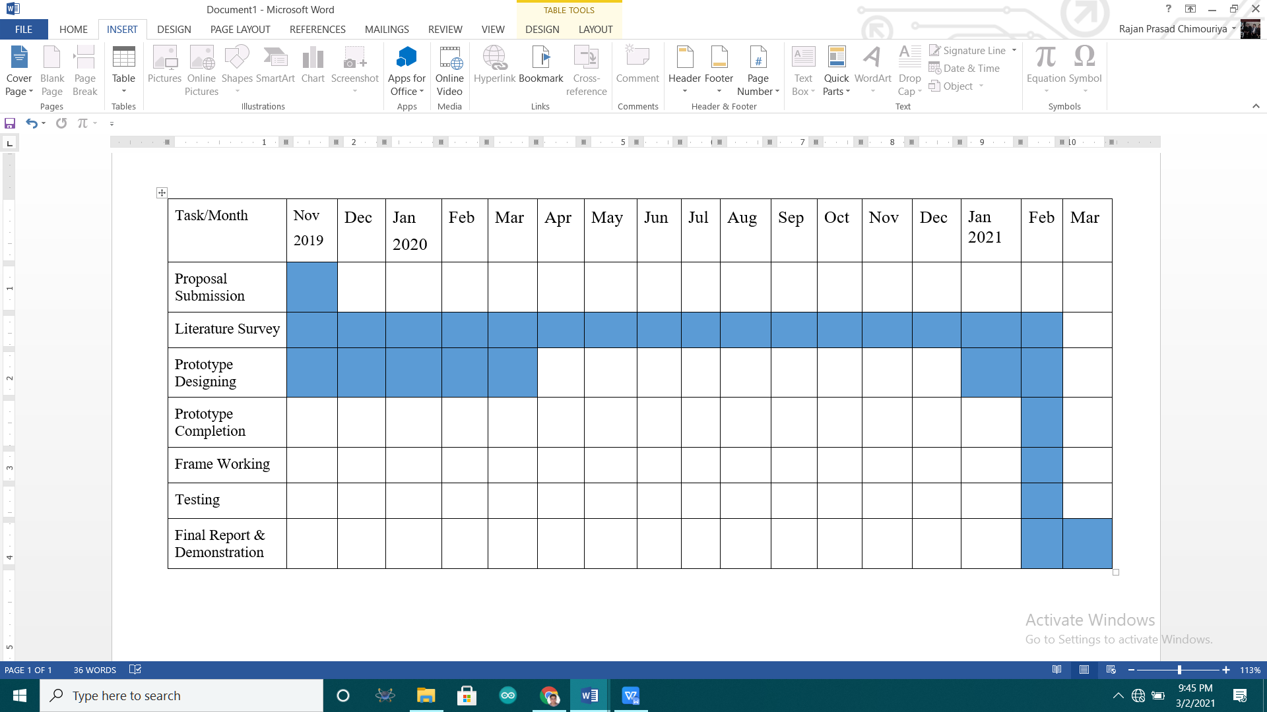

Index

Task Completed

The project is yearly project; project should be completed within 8 months but due to lockdown caused by Nobel COVID-19 it couldn't be completed in time. It took 17 months to complete this project and submit before deadline. So, at lockdown project members expanded knowledge surveying and doing research; most of those survey couldn't be included in report. But, finally hardware is successful and working.

Mostly in lockdown simulation was done in proteus and project members expanded knowledge in aurdino code. Also, various parameters of distribution line was studied. Project members also learned Simulink.

## 3.6 Summary

In this chapter, the methodology for the successful completion of the project is included. The chapter begin with block diagram of system. Then in another section there is circuit diagram, flowchart of the code, working principle of the system. The chapter end with Gantt chart.

## CHAPTER 4: SYSTEM ANALYSIS AND RESULT

## 4.1 Proteus Simulation

### 4.1.1 Simulation: RMS current and voltage measurement

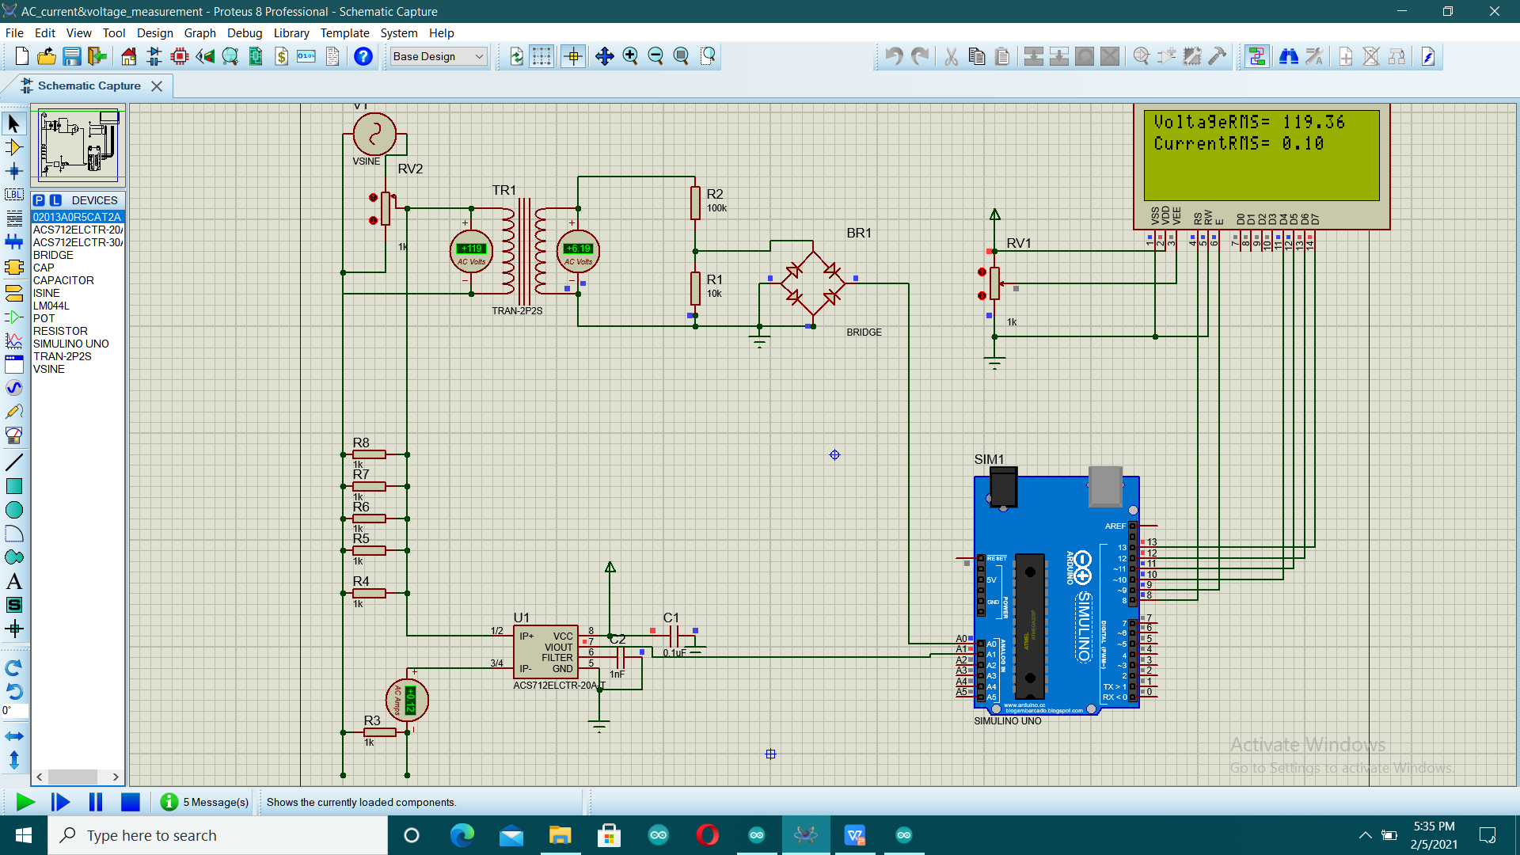

Fig 3.0 Simulation: RMS current and voltage measurement

Proteus 8.0 was used for simulating circuit and aurdino code. Before implementing overall system in hardware, single phase voltage and current was measured in proteus. High voltage is step down and rectified and sent to aurdino. Aurdino has internal ADC of 10 bit resolution. This ADC is converted into analogue value and is displayed in LCD as shown in the circuit.

Current Sensor ACS712 is used to sense AC current. This AC current is converted into AC voltage of offset 2.5 volt. The reading and calibration was done. And finally current is also displayed in LCD.

The value in Ammeter and voltmeter are matched with displayed value.

4.1.2 Simulation: Phase angle measurement 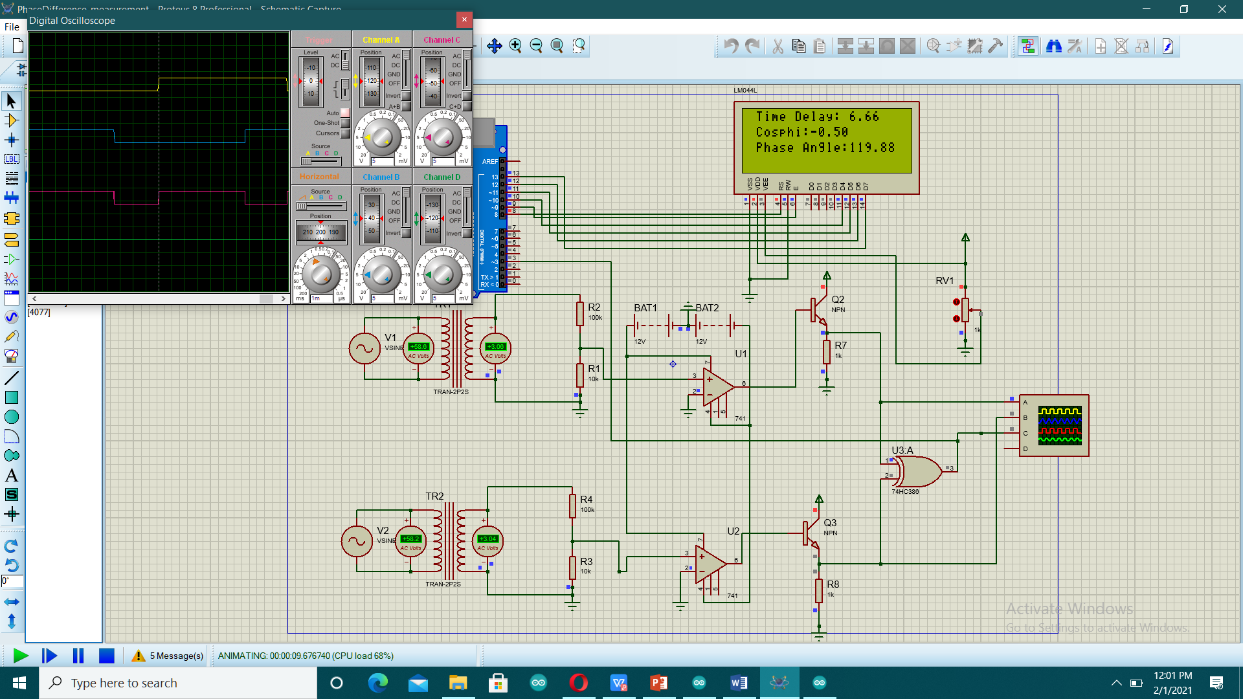

Fig 3.1 Simulation: Phase angle measurement

In three phase supply, voltage between two phases lags by 120 degrees (6.67 ms). This is measured successfully in proteus.

For this two voltage supply blocks are used and the phase angle between them is varied by 120 degree. And then by implementing Zero cross detector circuit and pulseln() function of aurdino, the result is displayed in LCD.

### 4.1.3 Simulation: When there is no fault at distribution line

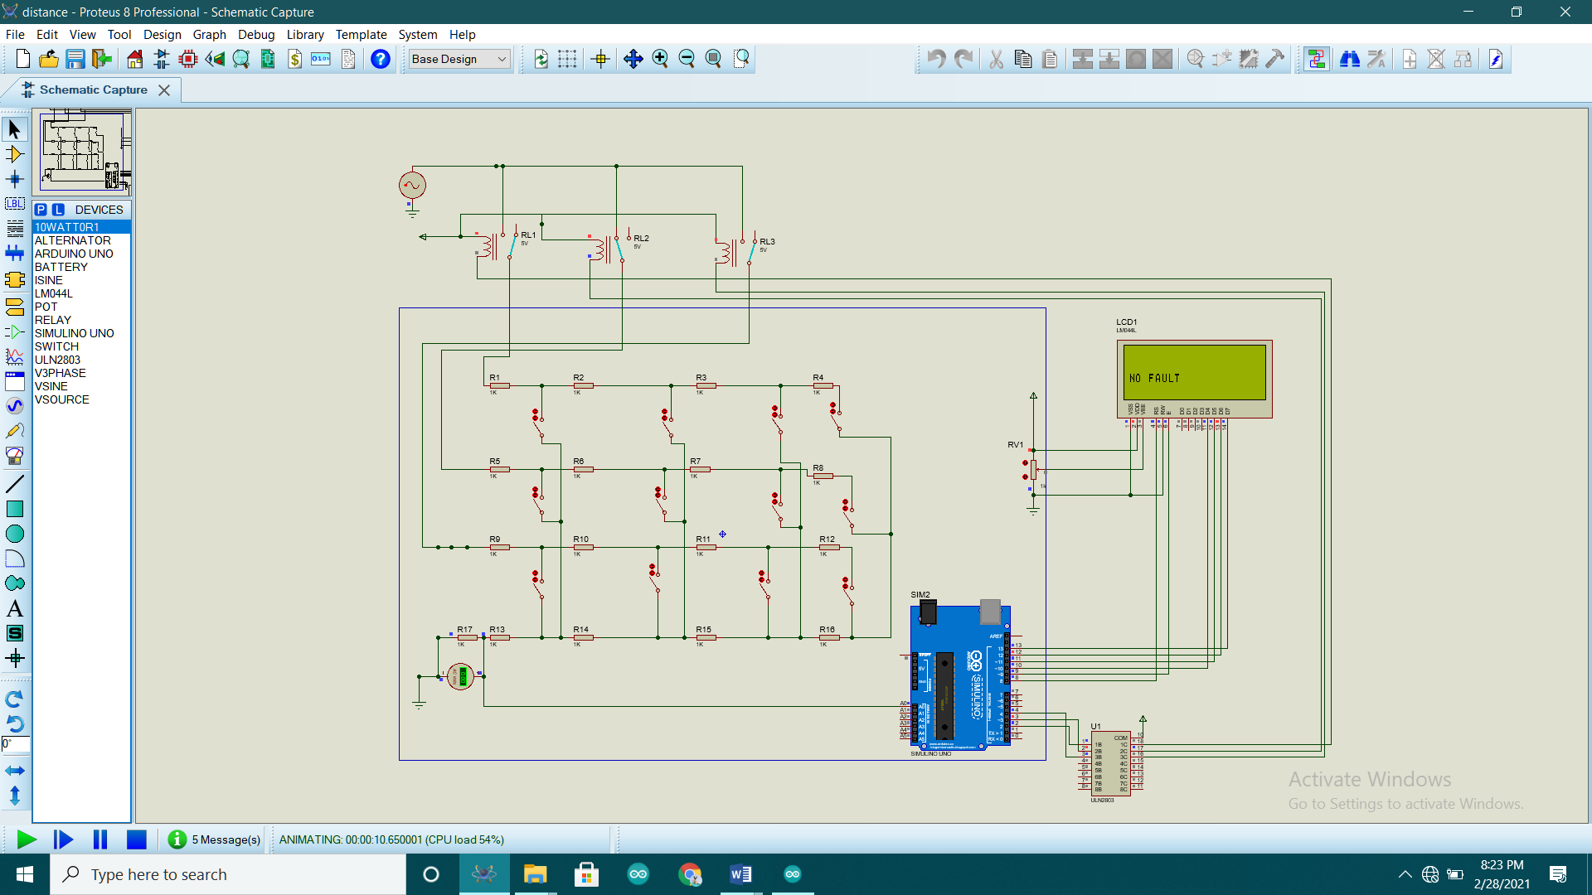

Fig 3.2 Simulation: When there is no fault at distribution line

This is the simulation of overall system in proteus. The working mechanism of the circuit is already discussed in Chapter 2.

When all the switches are open as shown in figure 3.2, the information on LCD is "NO FAULT".

4.1.4 Simulation: When there is single line to ground fault at 2 KM.

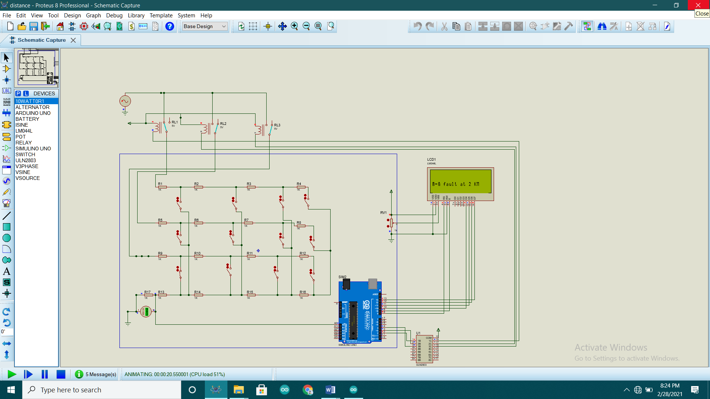

Fig 3.3 Simulation: When there is single line to ground fault at 2 KM.

Now, in this case at 2 KM distance a switch is pressed between B line and neutral. And the information at LCD displays "B-G fault at 2 KM".

Similarly, if another switch is pressed at 2 KM, the information would be "R-G fault at 2 KM". If another switch is pressed at 4 KM, the information would be "Y-G fault at 4 KM".

### 4.1.5 Simulation: When there is double line to ground fault at 4 KM.

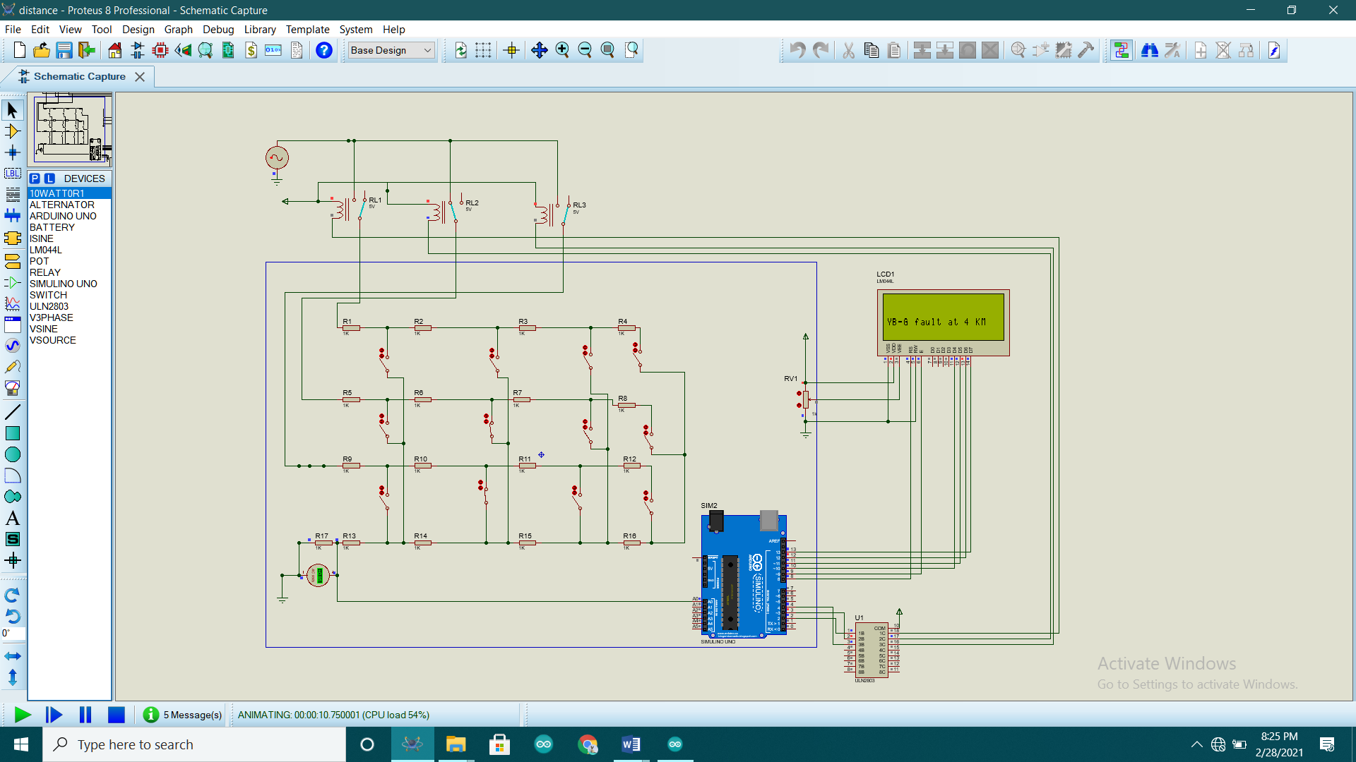

Fig 3.4 Simulation: When there is double line to ground fault at 4 KM.

Similarly, when 2 switches are pressed simultaneously at 4 KM the information at display shows "YB-G fault at 4 KM". When any two switches at any distance are pressed display shows respective fault at respective distance.

4.1.6 Simulation: When there is triple line to ground fault at 8 KM

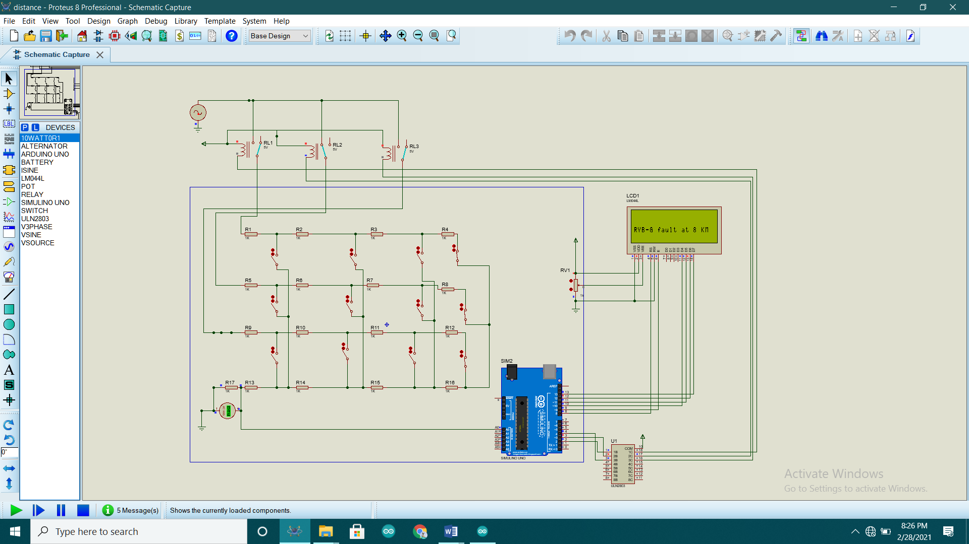

Fig 3.5 Simulation: When there is triple line to ground fault at 8KM

Similarly, when 3 switches are pressed simultaneously at 8 KM the information at display shows "RYB-G fault at 8 KM". When any three switches at any distance are pressed display shows respective fault at respective distance.

## 4.2 Hardware Implementation

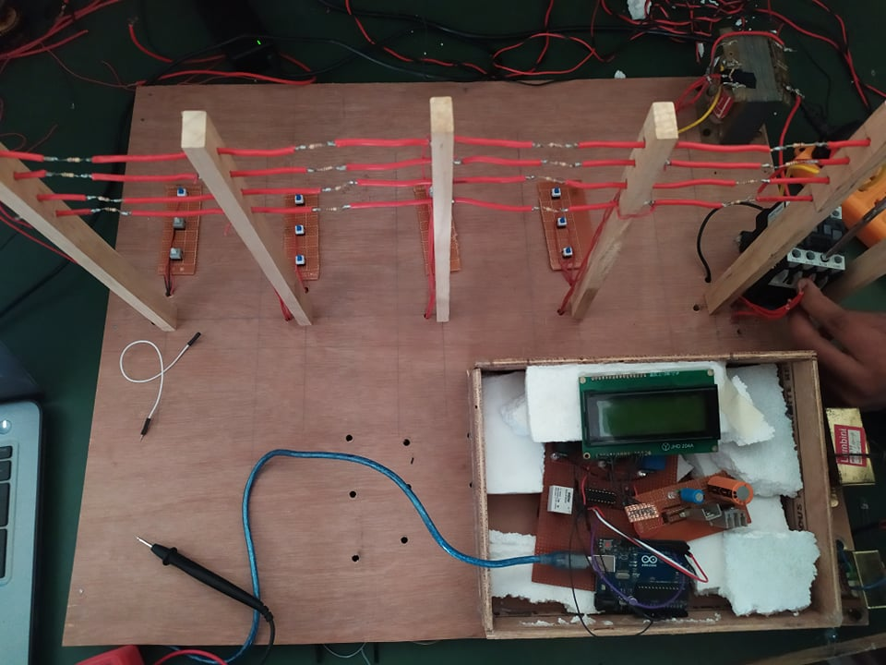

Fig 3.6 Hardware Implementation

In hardware, 3 transformers are used to step down the 220 V line to neutral to 12 V line to neutral. This 12 volt flows in this distribution line. So, when there is fault the return voltage of three phase at different distance is mentioned in the following table. The data is calculated from our hardware implemented system.

|  |  |  |  |  |  |  |  |  |
| --- | --- | --- | --- | --- | --- | --- | --- | --- |
| Single line to ground fault | Distance  (2 KM) | | Distance  (4 KM) | | Distance  (6 KM) | | Distance  (8 KM) | |
|  | Return voltage | equivalent ADC | Return voltage | equivalent ADC | Return voltage | equivalent ADC | Return voltage | equivalent ADC |
| No fault | 0 | 0 | 0 | 0 | 0 | 0 | 0 | 0 |
| R-G | 2.5 | 795-800 | 1.5 | 533-537 | 1.1 | 402-203 | 0.8 | 320-325 |
| Y-G | 2.5 | 795-800 | 1.5 | 533-537 | 1.1 | 402-203 | 0.8 | 320-325 |
| B-G | 3.3 | 1012-1020 | 1.9 | 623-627 | 1.3 | 450-451 | 0.9 | 350-357 |

Table 1.1 Voltage and equivalent ADC for single line to ground fault

## 4.3 Features of the final project

Final project is simple and can be used for study purpose. Some features of this project are:

* The primary of three transformer can be given to single phase AC supply using extension board or three lines of primary can be given to three phase supply. The voltage it can work with is 217 volt to 227 voltage Line to Neutral. It doesn't work if the voltage is outside this range.
* It take about 1000 ms to check the fault at all 3 phases.
* There is a contactor in the project which cut off the voltage when fault occurs. And after the fault is detected fault clearing time given is 10 second at which the fault has to be cleared.
* The project is simple, circuit is easy to understand and cheap.

## 4.4 Cost Estimation of project

Total cost of project = electronic components + furniture + Soldering electric bill + labor cost

Cost of electronic components = 17 * resistor + 16 * hold switch +1*Matrix board + 1*Aurdino Uno + 1* 2803 IC +1*7806 IC+ 1* Capacitor + 1*contactor + 4* relay

= 17 * 10 + 16* 10 +1*20 + 1*1000 + 1*50 + 1*60 + 1*30 + 1*300 + 4 * 35

= Rs. 1,930 only

Furniture = Rs. 1,000 only

Soldering electric Bill = Soldering time (in hour)* 60 Watt/1000

= 20*60/1000 = Rs. 1.2 only

labour cost = Rs. 30,000 only

Therefore, total cost = 1930+1000+1.2+30000 = 33,000 only

## 4.5 Summary

This chapter includes results and conclusion obtained doing this project. In section 4.1, proteus simulation of various tests are included. In section 4.2, hardware implementation of project is included. In section 4.3, final feature of project is included. The chapter ends with cost estimation of project. The cost estimation of project is around 33,000 only.

# CHAPTER 5: CONCLUSION AND FUTURE RECOMMENDATION

The electric utilities companies are expected to provide consumers with a continuous and high quality service at a competitive and reasonable cost. This means that they have to insure the reliability of the system to provide consumers with a service what is consistent with the safety personnel and equipment, and meet their demands within specified voltage and frequency. Faults in the transmission lines are one of the elements that the reliability of the system is affected by. The more faults that take place, the less reliable the system is, since they could cause outages in the power system, which may result in an interruption of the service.

Some improvements that can be done on the project are:

* Using different arduino in different phases thereby decreasing time delay.
* Improving algorithm to detect LL and LLL faults.

# REFERENCES

1. Dalstein, Thomas and Kulicke, Bernd (April 1995). Neural Network Approach to Fault Classification for High speed Protective Relaying. IEEE Transactions on Power Delivery, 10 (2), 1002-1009.
2. Deshpande, M.V. (1984) Electric Power Systems. 62-75. Tata McGrew-Hill Publishing Company Limited.
3. Eaton, J. Robert, and Cohen, Edwin (1983).Electric Power Transmission Systems, (2nd Ed.). Prentice-Hall Inc.
4. MacDonald (1969). Power System Protection, 1, The Electricity Council.
5. Fonseca, J.R., Tan, A.L., Monassi, V., Janquira, W.S., Silva, R.P., Assuncano, L.A.R., and Melo, M.O.C. (April 1990) Effects of Agricultural Fires on the Performance of Overhead Transmission Lines. IEEE Transactions on Power Delivery, 5(2), 687-694.
6. Furukawa, Shuji, Usada, Osamu, Isozaki, Tashaki, and Irie, Tashaki (October 1989). Development and Application of Lightning Arresters for Transmission Lines. IEEE Transactions on Power Delivery, 4(4), 2121-2127
7. Gonen, Turan, (1988). Electric Power Transmission System Engineering: Analysis and Design. John Wiley & Sons.
8. Gonen, Turan (1987). Modern Power System Analysis. John Wiley and Sons.
9. Urasawa, K., Kanemaru, K., Toyota, S,. and Sugiyama, K. (October 1989). New Fault Location System For Power Transmission Lines Using Composite Fiber-Optic Overhead Grounding Wire (OPGW). IEEE Transactions on Power Delivery, 4, 2005-2011.
10. Simulink Library Reference Manual, The Mathworks.

# APPENDIX A : DATASHEET

ULN 2803 IC

1. Pin configuration

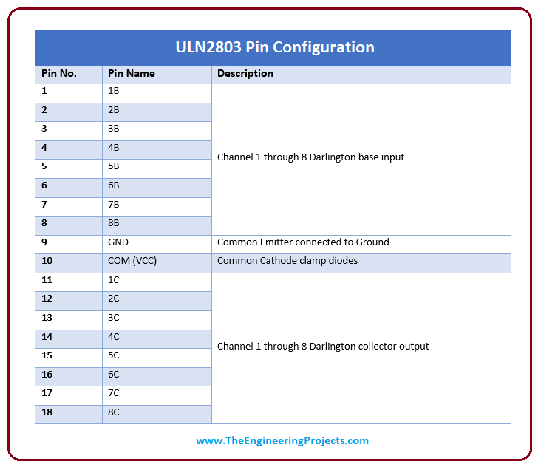

1. Maximum Rating

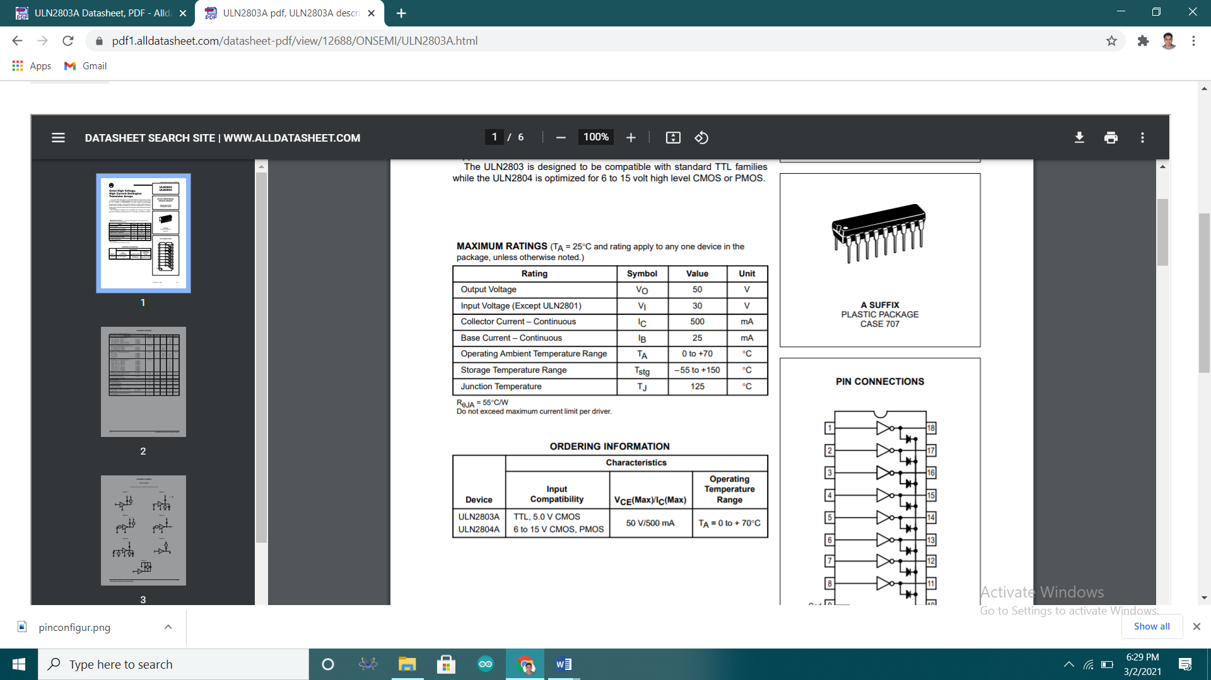

# APPENDIX B: CODE FOR FINAL HARDWARE

## LCD Programme

#include <LiquidCrystal.h>

int adcGenerator();

int faultDistance(int);

LiquidCrystal lcd(8,9,10,11,12,13);

const int analog_channel = A0;

int adcValue,readValue;

int r,y,b;

int timer, timer1, timer2;

int faultclearingtime=10000;

void setup() {

pinMode(2,OUTPUT);

pinMode(3,OUTPUT);

pinMode(4,OUTPUT);

pinMode(5,OUTPUT);

lcd.begin(20,4);

lcd.print("FAULT LOCATION AND CLASSIFICATION");

delay(1000);

lcd.clear();

}

void loop() {

//calculation for r fault:

lcd.clear();

digitalWrite(2,HIGH);

digitalWrite(3,LOW);

digitalWrite(4,LOW);

digitalWrite(5,LOW);

adcValue=adcGenerator();

lcd.setCursor(0,0);

lcd.print(adcValue);

lcd.setCursor(5,0);

r=faultDistance(adcValue);

lcd.print(r);

delay(500);

digitalWrite(2,LOW);

digitalWrite(3,LOW);

digitalWrite(4,LOW);

digitalWrite(5,LOW);

delay(500);

//calculation for y fault

digitalWrite(2,LOW);

digitalWrite(3,HIGH);

digitalWrite(4,LOW);

digitalWrite(5,LOW);

adcValue=adcGenerator();

lcd.setCursor(0,1);

lcd.print(adcValue);

lcd.setCursor(5,1);

y=faultDistance(adcValue)

lcd.print(y);

delay(500);

digitalWrite(2,LOW);

digitalWrite(3,LOW);

digitalWrite(4,LOW);

digitalWrite(5,LOW);

delay(500);

//calculation for b fault

digitalWrite(2,LOW);

digitalWrite(3,LOW);

digitalWrite(4,HIGH);

digitalWrite(5,LOW);

adcValue=adcGenerator();

lcd.setCursor(0,2);

lcd.print(adcValue);

lcd.setCursor(5,2);

b=faultDistance(adcValue);

lcd.print(b);

delay(500);

digitalWrite(2,LOW);

digitalWrite(3,LOW);

digitalWrite(4,LOW);

digitalWrite(5,LOW);

delay(500);

//CLASSIFYING TYPE OF FAULT

char buffer[19];

lcd.setCursor(0,3);

if(r==0 && y==0 && b==0){

sprintf(buffer,"NO FAULT ");

}

//TRIPLE LINE TO GROUND FAULT

else if(r==y && y==b){

sprintf(buffer,"RYB-G fault at %d KM", r);

}

//SINGLE LINE TO GROUND FAULT

else if(r>=2 && y==0 && b==0){

sprintf(buffer,"R-G fault at %d KM",r);

}

else if(r==0 && y>=2 && b==0){

sprintf(buffer,"Y-G fault at %d KM",y);

}

else if(r==0 && y==0 && b>=2){

sprintf(buffer,"B-G fault at %d KM",b);

}

//DOUBLE LINE TO GROUND FAULT

else if(r==y && b==0 && r>=2){

sprintf(buffer,"RY-G fault at %d KM",r);

}

else if(r==0 && y==b && y>=2 ){

sprintf(buffer,"YB-G fault at %d KM",y);

}

else if(r==b && y==0 && b>=2){

sprintf(buffer,"RB-G fault at %d KM",b);

}

lcd.print(buffer);

if(r==0 && y==0 && b==0){

digitalWrite(2,LOW);

digitalWrite(3,LOW);

digitalWrite(4,LOW);

digitalWrite(5,LOW);}

else {

digitalWrite(2,LOW);

digitalWrite(3,LOW);

digitalWrite(4,LOW);

digitalWrite(5,HIGH);

int j=5;

timer1=millis();

while(j==5){

timer2=millis();

timer=timer2-timer1;

if(timer==faultclearingtime){j=4;}

}

}

}

int adcGenerator(){

int maxValue = 0;

int minValue = 1023;

uint32_t start_time = millis();

while((millis()-start_time) < 250){

readValue = analogRead(analog_channel);

if (readValue > maxValue){

maxValue = readValue;

}

if (readValue < minValue){

minValue = readValue;

}

}

return(maxValue-minValue);

}

int faultDistance(int adcValue){

if (adcValue>=0 && adcValue<=100){

return 0;

}

else if (adcValue>=750 && adcValue<=1023){

return 2;

}

else if (adcValue>=520 && adcValue<=650){

return 4;

}

else if (adcValue>=390 && adcValue<=480){

return 6;

}

else if (adcValue>=300 && adcValue<=375){

return 8;

}

}

## Code for serial monitor

int adcGenerator();

int faultDistance(int);

const int analog_channel = A0;

int adcValue,readValue;

int r,y,b;

int wt=250;

int timer, timer1, timer2;

int faultclearingtime=10000;

void setup() {

pinMode(2,OUTPUT);

pinMode(3,OUTPUT);

pinMode(4,OUTPUT);

pinMode(5,OUTPUT);

Serial.begin(9600);

}

void loop() {

//calculation for r fault:

digitalWrite(2,HIGH);

digitalWrite(3,LOW);

digitalWrite(4,LOW);

digitalWrite(5,LOW);

adcValue=adcGenerator();

Serial.println(" ");

Serial.print(adcValue);

Serial.print(" ");

r=faultDistance(adcValue);

Serial.print(r);

Serial.print(" ");

delay(wt);

digitalWrite(2,LOW);

digitalWrite(3,LOW);

digitalWrite(4,LOW);

digitalWrite(5,LOW);

delay(wt);

//calculation for y fault

digitalWrite(2,LOW);

digitalWrite(3,HIGH);

digitalWrite(4,LOW);

digitalWrite(5,LOW);

adcValue=adcGenerator();

Serial.print(adcValue);

Serial.print(" ");

y=faultDistance(adcValue);

Serial.print(y);

Serial.print(" ");

delay(wt);

digitalWrite(2,LOW);

digitalWrite(3,LOW);

digitalWrite(4,LOW);

digitalWrite(5,LOW);

delay(wt);

//calculation for b fault

digitalWrite(2,LOW);

digitalWrite(3,LOW);

digitalWrite(4,HIGH);

digitalWrite(5,LOW);

adcValue=adcGenerator();

Serial.print(adcValue);

Serial.print(" ");

b=faultDistance(adcValue);

Serial.print(b);

Serial.print(" ");

delay(wt);

digitalWrite(2,LOW);

digitalWrite(3,LOW);

digitalWrite(4,LOW);

digitalWrite(5,LOW);

delay(wt);

//CLASSIFYING TYPE OF FAULT

char buffer[19];

if(r==0 && y==0 && b==0){

sprintf(buffer,"NO FAULT ");

}

//TRIPLE LINE TO GROUND FAULT

else if(r==y && y==b){

sprintf(buffer,"RYB-G fault at %d KM", r);

}

//SINGLE LINE TO GROUND FAULT

else if(r>=2 && y==0 && b==0){

sprintf(buffer,"R-G fault at %d KM",r);

}

else if(r==0 && y>=2 && b==0){

sprintf(buffer,"Y-G fault at %d KM",y);

}

else if(r==0 && y==0 && b>=2){

sprintf(buffer,"B-G fault at %d KM",b);

}

//DOUBLE LINE TO GROUND FAULT

else if(r==y && b==0 && r>=2){

sprintf(buffer,"RY-G fault at %d KM",r);

}

else if(r==0 && y==b && y>=2 ){

sprintf(buffer,"YB-G fault at %d KM",y);

}

else if(r==b && y==0 && b>=2){

sprintf(buffer,"RB-G fault at %d KM",b);

}

Serial.print(" ");

Serial.print(buffer);

delay(wt);

if(r==0 && y==0 && b==0){

digitalWrite(2,LOW);

digitalWrite(3,LOW);

digitalWrite(4,LOW);

digitalWrite(5,LOW);}

else {

digitalWrite(2,LOW);

digitalWrite(3,LOW);

digitalWrite(4,LOW);

digitalWrite(5,HIGH);

int j=5;

timer1=millis();

while(j==5){

timer2=millis();

timer=timer2-timer1;

if(timer==faultclearingtime){j=4;}

}

}

}

int adcGenerator(){

int maxValue = 0;

int minValue = 1024;

uint32_t start_time = millis();

while((millis()-start_time) < 250){

readValue = analogRead(analog_channel);

if (readValue > maxValue){

maxValue = readValue;

}

if (readValue < minValue){

minValue = readValue;

}

}

return(maxValue-minValue);

}

int faultDistance(int adcValue){

if (adcValue>=0 && adcValue<=100){

return 0;

}

else if (adcValue>=750 && adcValue<=1023){

return 2;

}

else if (adcValue>=520 && adcValue<=650){

return 4;

}

else if (adcValue>=390 && adcValue<=480){

return 6;

}

else if (adcValue>=300 && adcValue<=375){

return 8;

}

}